. A rectangular loop of wire with sides H = 30 cm and W = 65 cm carries current I2 = 0.383 A. An infinite straight wire, located a distance L = 34cm from segment ad of the loop as shown, carries current I1 = 0.598 A in the positive y-direction.
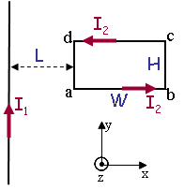
1) What is Fad,x, the x-component of the force exerted by the infinite wire on segment ad of the loop?
2) What is Fbc,x, the x-component of the force exerted by the infinite wire on segment bc of the loop?.
3) What is Fnet,y, the y-component of the net force exerted by the infinite wire on the loop?
. Another infinite straight wire, aligned with the y-axis is now added at a distance 2L = 68 cm from segment bc of the loop as shown. A current, I3, flows in this wire. The loop now experiences a net force of zero.
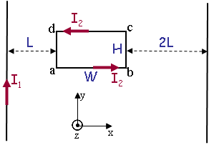
4) What is the direction and magnitude of I3?

